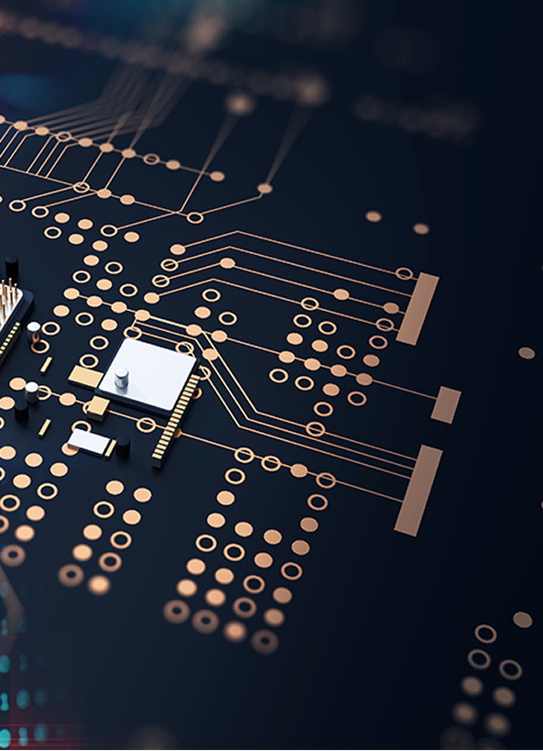

**Published by:**

**Jurusan Teknik Elektromedik, Politeknik Kesehatan Kemenkes Surabaya, Indonesia**



**JEEEMI**

**pp. 115-190**

**July**

**2022**

**Vol.4**

**Issue 3**

**e-ISSN**

**2656-8632**